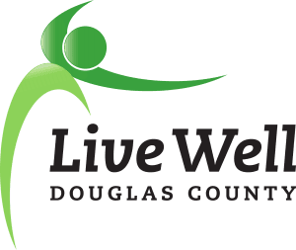

Vision: Communities where we all thrive.
Mission: Leading a movement to build communities that support the health and well-being of all.

Our Story
Established in 2008, LiveWell Douglas County is a cross-sector community coalition that works to improve the health and well-being of residents of Lawrence and Douglas County. Utilizing a collective impact framework, LiveWell Douglas County understands that community-wide issues require long-term engagement from numerous community agencies and individuals. We provide a platform where individuals and organizations come together on collective work that affects change at a level greater than any one institution could achieve alone. LiveWell Douglas County has set an example across Kansas, demonstration that selfless collaboration can lead to system- and community-wide issue identification and resolution.
Since its inception, LiveWell Douglas County has grown to include hundreds of community residents and scores of community partners. Local achievements are numerous, and include the founding of WorkWell Lawrence and Lawrence Complete Streets, establishment of marathon clubs at local schools, establishment and growth of summer food programs across Douglas County, building trails at Eudora Elementary School, establishment and growth of Double Up Food Bucks, introduction of FuelGood to bring healthy foods and beverage options to public spaces, increased food recovery and redistribution efforts, and creation of the Lawrence Loop.
We’ve seen improved access to nutritious food, increased connectivity of bike and pedestrian networks, programs that support the health of our youth, support for healthier work environments, advancing policies to minimize tobacco use and purchase, and work to prevent sexual violence. As we look forward to the next 10 years, we hope to build on these successes while addressing gaps and inequities in health through the type of strong, community-based support that LiveWell was founded on.
Our Future
LiveWell has a strong base of engaged community stakeholders, as well as communications and data support from the Lawrence-Douglas County Health Department and K-State Research and Extension – Douglas County. We would like to seize the opportunity to accelerate the growth of local efforts by providing staff support for grant writing, communications, and to strengthen community engagement by hiring an Executive Director. This position will further leverage the incredible in-kind donations of time provided by community members, and allow dedicated time for securing additional support and resources to expand LiveWell’s efforts in Douglas County. We hope that you will join the effort to establish this critical position as we look toward the next decade of strong coalition work ahead of us.
Sincerely,

The 2018-2019 LiveWell Douglas County Executive Team

